**we are London based digital designers delivering world-class results every time**

**Smart web solutions for your small business**

**Get your website, email and business online today!**

**We Design your world**

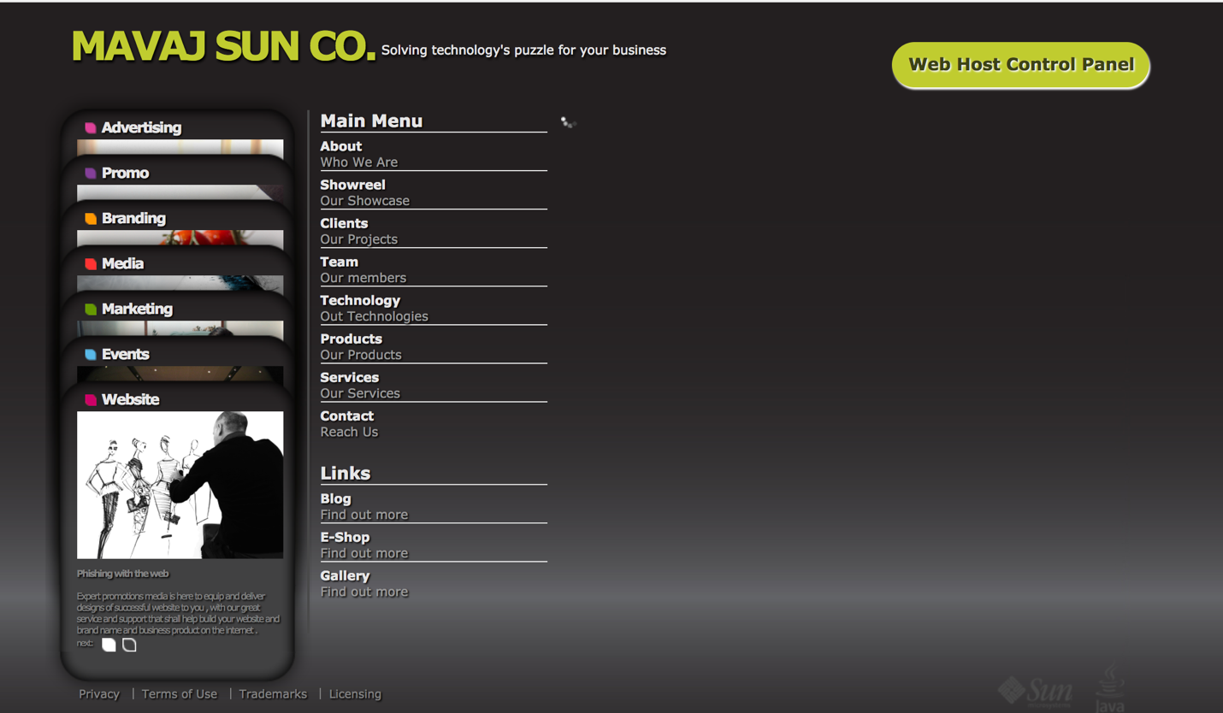

**Advertising**

* We design your advert

Putting our heads together

Our mission begins with your brief; we put our heads together in a brain storm session to come up with a layout that shall define the concept of an advertising design to meet your objectives with a combination of clear thinking and a creative layout.</br>

We create advertising concepts that embody an idea that makes it real, we design campaigns that have the power to inform, educate, persuade and ultimately sell.

More Ideas

Effective Concepts

Attractive layout

--------------------------------------------------------------

**Website**

--We design your wesite

Phishing with the web

Expert promotions media is here to equip and deliver designs of successful website to you, with our great service and support that shall help build your website , brand name and business product on the internet .<br/>

We really care about the innovation, quality and services that we provide to our customers and this will show in your dealings with us.

Creative Thinking

Inventive Solutions

Interactive Support

-----------------------------------------------------------------------

**Branding**

We design your brand

Never limit your brand

We’re a fresh innovative Branding company with fresh ideas that is truly able to define and drive your company’s image and brand as well in establishing long term relationships with our clients. <br/>

MAVAJ SUN CO is here to equip you with services that shall help you build your brand and market your business on and off the internet. <br/>

We are an agency that really cares about the quality of service. We gave our customers the edge and this will show in your dealings with us. <br/>

Clear Objectives

Defined Targets

Confirmed Results

-------------------------------------------------------------------------------------------------

**Media**

We design your media

Media results beyond the norm

MAVAJ SUN Co can help you reach with your media campaign any niche of audience through our experience in media planning with initial strategy and concepts to full implementation with continuous monitoring of results.<br/>

Every project we take on shall be planned carefully, and distributed to the different mediums according to your marketing and media plan. We work close to you and choose the right solutions to showcase your brand or product.

Better Exposure

Definite Placement

Niched Audience

**Marketing**

Exposure through innovation

MAVAJ SUN CO is a marketing expert that knows how to dig deeper and work smarter to secure your marketing plan and deliver results, by taking a neutral and holistic approach. <br/>

We gave clients an outside view of their current market status and help shape its future goals. <br/>

We do this through extensive market study and assessment to come out with a suitable marketing plan attached with an effective media plan. <br/>

We make sure that you spend your budget at the right time and in the right place.

True Advice

Distinct Strategy

**Events**

We design your events

A date to remember

We make thing happen for your event. Starting from event set up to PR. To exhibition stands and give away items. <br/>

We drive your event into success and insure that your company’s image is consistent across all means of communication. <br/>

MAVAJ SUN CO can and shall deliver any event or exhibition management from A-Z.

Ingenious Display

Ground Breaking Theme

Satisfied Audience

**Promo**

We design your promo

A promotion to last

MAVAJ SUN CO has a wide variety of promotion and gift items that delivers your correct branding message and introduces your event effectively. <br/>

Promotion items can be a double bladed tool. Sending out promotional items to an exhibition or an events or seminar could sometimes be a waste of money other being a useless effort. <br/>

We can custom make and print on any shape or design to any gift item no matter the size is and the material it is make of . <br/>

Our prices are comprehensive and our guarantee and service are reliable.

True Service

Reasonable Cost

Prompt Delivery

**Portfolio / Showcase / Demo**

Portfolio

Interactive Movie

About **/ Who We Are**

Payoda Inc is an Information Technology services and solutions and IT staffing solutions provider serving businesses globally since 2005. Headquartered in the United States, with an offshore development center in India, Payoda is committed to make the customers see real, tangible ROI. We are dedicated to the success of our customers. Fittingly, the name “Payoda” has its origins in the Sanskrit words ‘Rain-bearing cloud’.

Payoda has sustained an impressive growth rate in both capability and profitability and is now positioned to be one of the major contributors in various sectors such as, Pharmaceutical & Life Sciences, Transportation, Media, Banking and Financial services, Insurance, Textile, Manufacturing, Retail, Utilities and others. At Payoda, we are continually undergoing a transformation and reorientation in response to the rapidly evolving needs of our clients. Payoda has in-depth experience of IT Services complemented with technical excellence and quality, to generate IT solutions for today and tomorrow.

PAYODA helps to achieve real business results that allow you to transform, and not just maintain, your operations. Our IT services, business solutions, and outsourcing bring you a level of certainty that no other competitor can match. You'll experience requirements that are met on-time, within budget, and with high quality; greater efficiency and responsiveness to your business; and the ability to shift investment to strategic initiatives rather than tactical functions.

**Management Team**

**Why Payoda?**

* The experience and expertise of our multi-talented technical team has perfected the art of choosing the right technology to suit your needs.
* Our unique agile development methodology that is feature driven is based on the best software development practices and our enormous experience. This ensures timely deliverables and at the same time increases our capability maturity level to provide you the software of excellent quality.

**Methodology**

*“Stepping beyond the normal practices......”*

Our rich experience with our global clientele has made us evolve a highly effective form of development methodology, an agile feature driven process that results in rapid analysis, design, development, implementation and maintenance of applications and customized solutions.

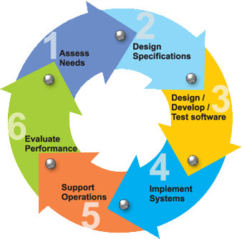

Our Team

Management

Creative Department

Web Department

Sale Department

True Passion

Deeper Insight

Greater Expert ise

WELCOME TO MAVAJ SUN CO

At MAVAJ SUN CO we excel in combining innovation and practicality to deliver unique solutions to our clients. Applied Innovation is the ability to infuse newer ideas and newer ways of doing things into all parts of the organization, and improve business outcomes, often without major disruptive change. It is a 360-degree business approach covering process, delivery, business and technology Innovations that help MAVAJ SUN CO to work collaboratively with clients for cost take-outs, speed to market and new business opportunities.

To see MAVAJ SUN CO in action , try the video demos on this page

Email US at [info@MavajSunCo.com](mailto:info@MavajSunCo.com) and let us put our big ideas to work for you .